**COMP 3069 -- Computer Graphics ( Project )**

**- for Autumn 2021 semester**

**(Weightage to final grade is 70%.)**

## Description

The project requires you to create a 3D scene by yourself. You may decide the content of the scene you create, which could be a scene from real world, or a virtual scene created by your imagination. The purpose of this proposed project is for you to demonstrate your knowledge of computer graphics techniques taught in the lectures and labs. ***We note that you are required use C or C++ programming with OpenGL library to do the programming, and you may use the Framework code we provided for this module if you need it for doing this project.*** And take as a priority to use the OpenGL library, such gl, glu, glut, and so on, you learned from lecture or lab session, and it is just an optional choice to use some other OpenGL library. No matter which OpenGL library you plan to use, you need to create some object models yourself, and write your own code to perform the operations or transformations which you want to do in the project. In the project, we also give credits for your new creative ideas being contributed in your project. Some example 3D scenes are given for your reference as follows:

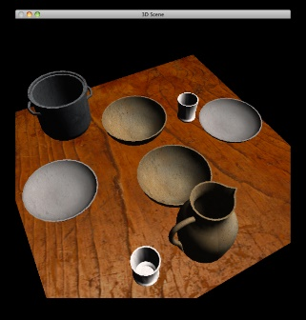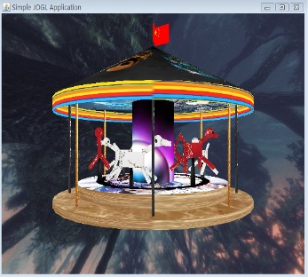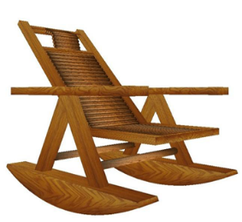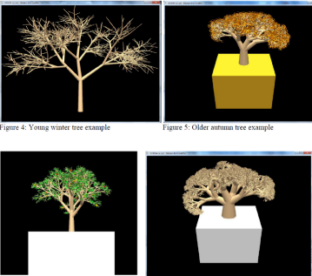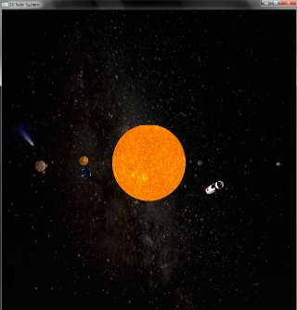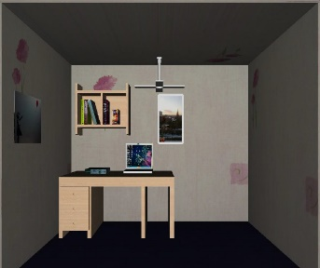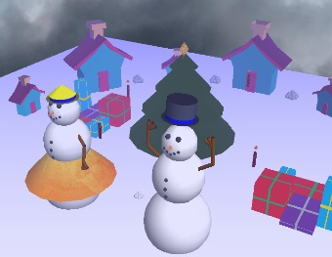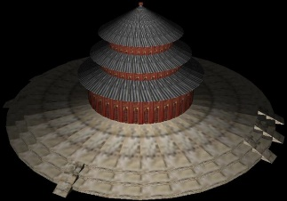

You are required to create a 3D scene with the following items: (**70% in total**)

* + Several 3D models, which may contain some own-created ones(compulsory/major part), and some imported objects (optional/minor part), (**15%**)
    - *Hint:* You may also like to design by yourself (non-imported ones) certain especially special or impressive model to obtain high marks in addition to some general models placed in the scene.
  + Transformation of models (scaling, translating, rotating), (**5%**)
  + Different viewpoint to the scene environment, (**5%**)
  + Animations for some objects in the scene, (**10%**)
    - *Hint:* You may also like to design certain especially special or impressive animation in addition to some general animations created in the scene (since *10% marks* are allocated to this item.).
  + Texturing –you need to employ texture to make some models look more realistic, (**10%**)
  + Lighting – you should apply lighting effect in your scene, (**5%**)
  + Some your own interesting creative ideas for adding special effects to the scene. (**15%**)
    - *Hint 1:* You may like to apply certain especially special, interesting or really impressive creative idea in addition to the general creative ideas applied in the scene (since *15% marks* are allocated to this item.).
    - *Hint 2:* For example, shadowing effect is a creative idea; a special animation is also a creative idea; a harmony aesthetic well-designed environment in the scene is again a creative idea; the idea of designing a procedure to make your sweeping robot in the room to sweep the whole area of the room is a creative idea too; etc
  + Good readability for program code, say with good structure, good style and appropriate comments of the source code. (**5%**)

Here we remark that the marks you obtained for each item of the above depend on ***how impressive*** the scene you creates is, the ***quality and aesthetic*** of objects or ***required components*** you produced in your scene, and the ***originality and complexity*** of the ideas you applied in the project.

## Proposal

In the first one and a half weeks, you need to submit **2-page** draft proposal of what you want to do for creating the 3D scene (although you could deviate a bit when you are progressing in doing your project). We expect that ***each student creates a different scene.***  **(4% marks)**

**Due date: 23:59 (midnight), 19 November 2021, Friday (China Time)**

**File name: CG_2021_ StuID_StuNAME_PROPOSAL.pdf**

## Full Program, Report, and Demo Video Clip

And then after several weeks, you need to submit a zip file including: full report, and source code.

* + Full report (**around 10 pages**) and Demo video clip (**of one minute to three minutes**):

Describing how to use your program, how you meet the requirements of the project, and your creative ideas contributed in creating the scene. Note that in your report, you *MUST* include a screenshot picture of your full scene you produced in your program. On the other hand, you need to create a video clip of one to three minutes to demonstrate the scene you create and its content.  **(16% marks)**

* + Source Code: (**see the beginning of this assignment sheet about the breakdown of the 65% marks for this part**)

Apart from the requirements described in the Description section, some credits are given for accounting for the readability, good structure, good style and good comments of the source code you write.  **(70% marks)**

**Due date: 4:00pm, 19 Dec. 2020, Sunday (China Time)**

**File name:**

**Zip file: CG_2021_StuID_StuNAME_PROJECT.zip,** which contains the following files**:**

**1. Full report: CG_2021_StuID_StuNAME_REPORT.pdf**

**2. Video clip: CG_2021_StuID_StuNAME_VIDEO.mp4**

**3. Source Code: Note: Free to name the files(“.cpp”, “.h”, etc)**

## In-class Presentation of Your Project and Program

Each of you is required to do an in-class presentation, including a short demo, of around 7 minutes to present what you have achieved in your project and you can show in the program you wrote. You would be assigned to one of **Group 1**, **Group 2**, **Group 3**, **Group 4** or **Group 5**. And the presentation order of the students for each group is listed as follows in the following pages (**Details are to be arranged (TBA)**).

**Group 1: Time: 3:00 pm – 6:00 pm, 16 December 2021, Thursday, Venue: PMB-432**

***Note that for the 4 international students in Group 1, please use the following online Teams link:***

[***https://teams.microsoft.com/l/meetup-join/19%3aNEbQJ1jaz_c-kjyGOiQMKFP25wE2cFdljEBkNTqYUos1%40thread.tacv2/1632970933048?context=%7b%22Tid%22%3a%2204c4c5c8-db8c-41b1-882b-5bb7948405e8%22%2c%22Oid%22%3a%22a9c0f010-158b-4393-a527-c112754dfd19%22%7d***](https://teams.microsoft.com/l/meetup-join/19%3aNEbQJ1jaz_c-kjyGOiQMKFP25wE2cFdljEBkNTqYUos1%40thread.tacv2/1632970933048?context=%7b%22Tid%22%3a%2204c4c5c8-db8c-41b1-882b-5bb7948405e8%22%2c%22Oid%22%3a%22a9c0f010-158b-4393-a527-c112754dfd19%22%7d)

**Group 2: Time: 3:00 pm – 6:00 pm, 16 December 2021, Thursday, Venue: TBA**

**Group 3: Time: 3:00 pm – 6:00 pm, 16 December 2021, Thursday, Venue: TBA**

**Group 4: Time: 1:00 pm – 3:00 pm, 16 December 2021, Thursday, Venue: PMB-432 or TBA**

**Group 4: Time: 1:00 pm – 3:00 pm, 16 December 2021, Thursday, Venue: TBA**

**(10% marks)**

**Due date for submitting the following presentation file: 23:59 midnight, 18 December 2021, Saturday**

**File name: CG_2021_StuID_StuNAME_Presentation.ppt**